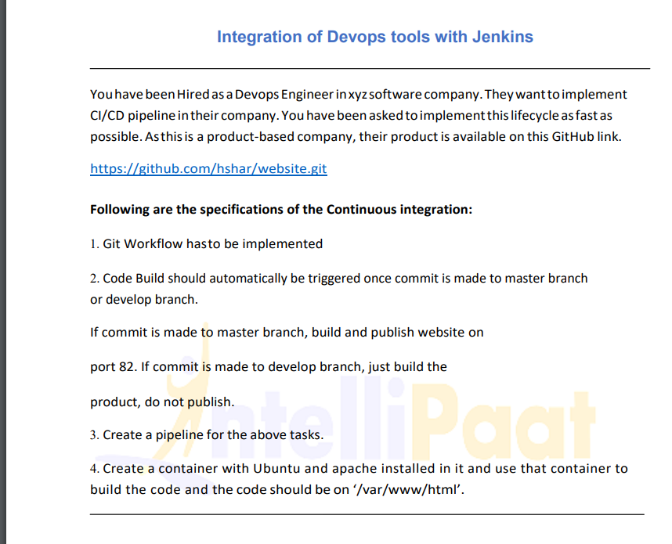

**Solution:**

I created /launched two EC2 instances (type-t2.micro) from AWS, will names one as master and other Slave/Node.

Then I installed java and Jenkins on master and java to node .And using the above provided git hub link I forked it to my account and then started operating as per the requirement in question.

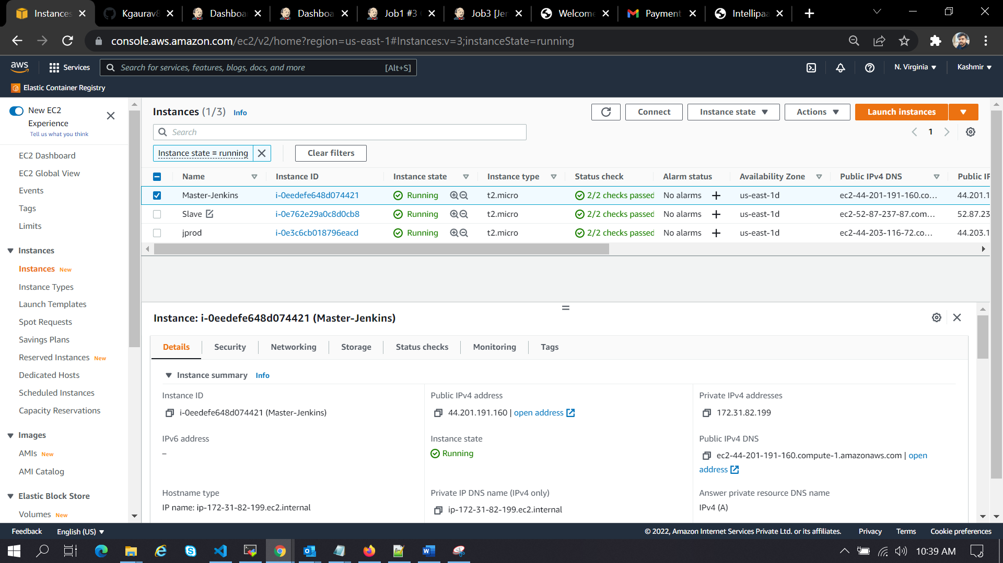

**Commands Used on master**:

1 clear

2 sudo apt-get update

3 sudo apt install ca-certificates

4 sudo apt-get install openjdk-11-jdk -y

5 wget -q -O - https://pkg.jenkins.io/debian-stable/jenkins.io.key | sudo apt-key add -

6 sudo sh -c 'echo deb https://pkg.jenkins.io/debian-stable binary/ > /etc/apt/sources.list.d/jenkins.list'

7 sudo apt-get update

8 sudo apt-get install jenkins -y

9 sudo apt-get install docker.io

10 systemctl status docker

11 ls

12 systemctl status jenkins

13 sudo apt-get install jenkins -y

14 jenkins

15 systemctl status jenkins

16 systemctl status docker

17 java -version

18 sudo cat /var/lib/jenkins/secrets/initialAdminPassword

19 cd .ssh

20 ls

21 ssh-keygen

22 ls

23 cat id_rsa.pub

24 cat id_rsa

25 cd

26 pwd

27 cd .ssh

28 ls

29 cat id_rsa.pub

30 cd

31 ls

32 git clone git@github.com:Kgaurav8/website-1.git

33 ls

34 cd website-1/

35 ls

36 sudo nano Dockerfile

37 git add .

38 git commit -m "commited my Dockerfile"

39 git branch

40 git push origin master

41 git branch develop

42 ls

43 git branch

44 git push origin develop

45 git branch

**On Slave Node:**

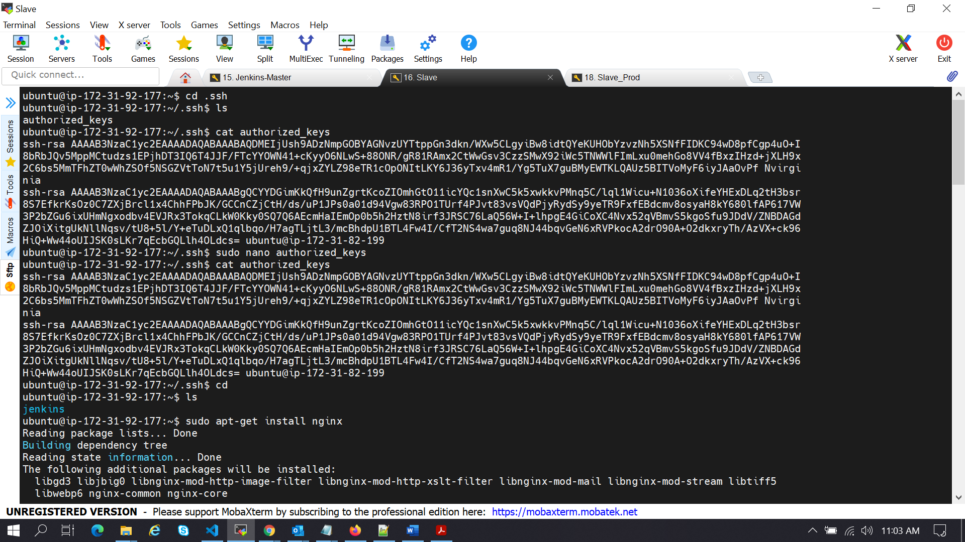

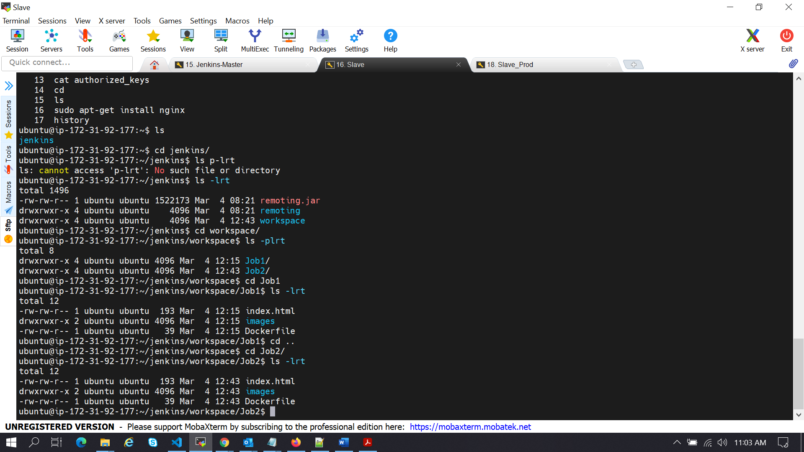

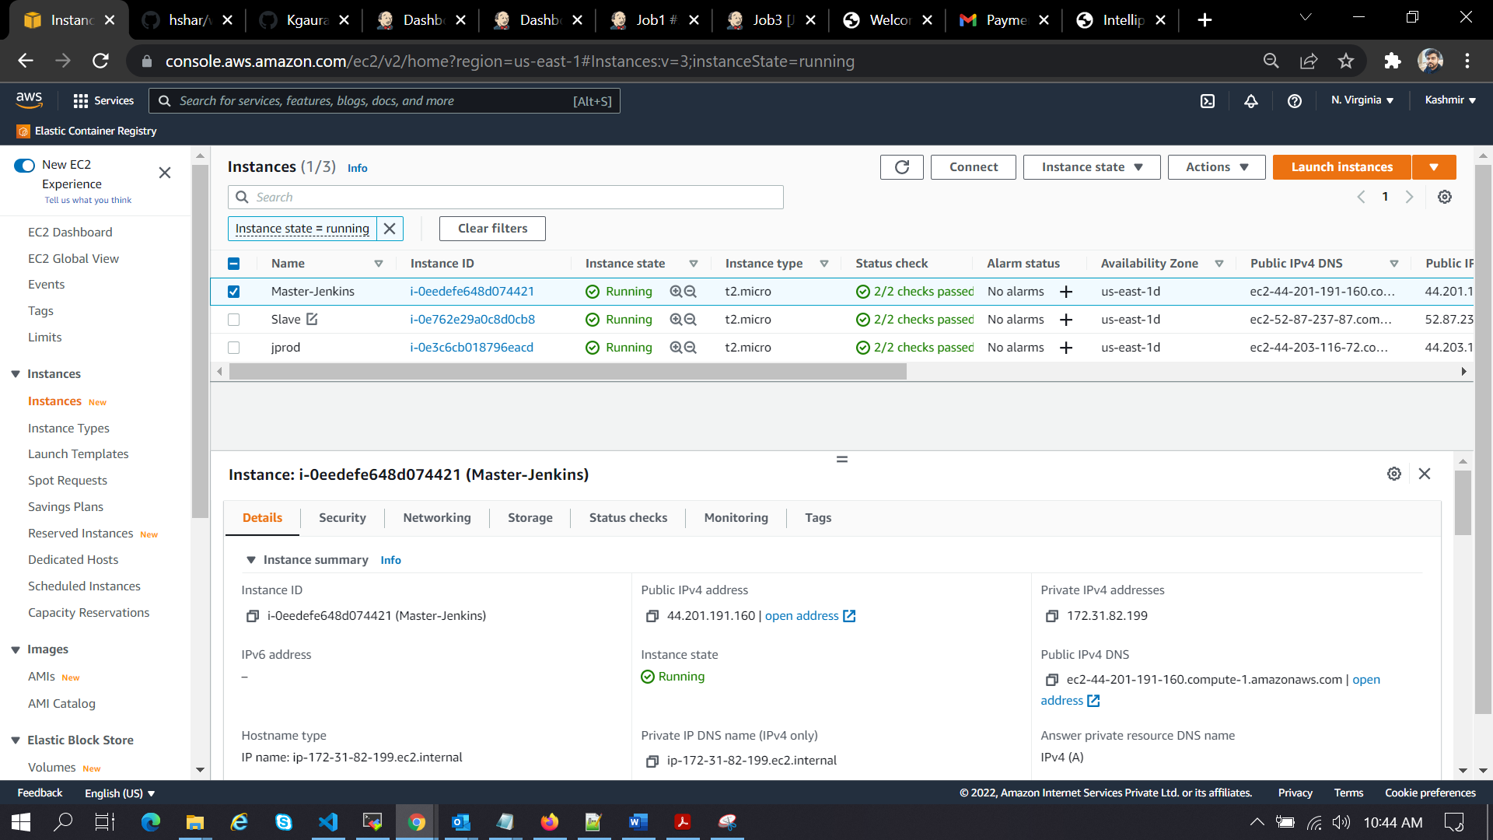

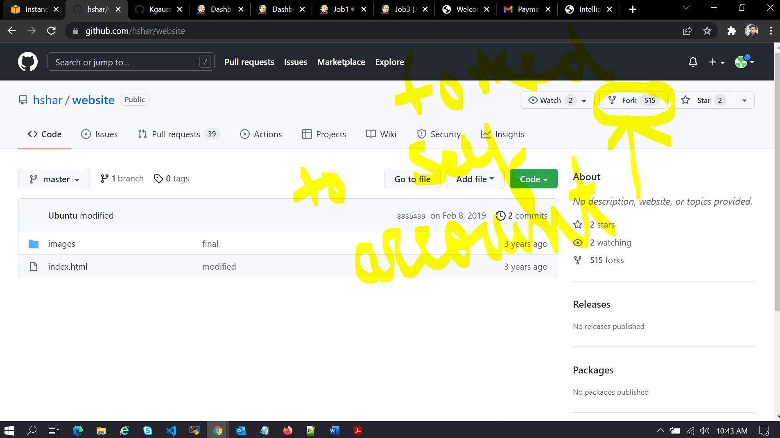

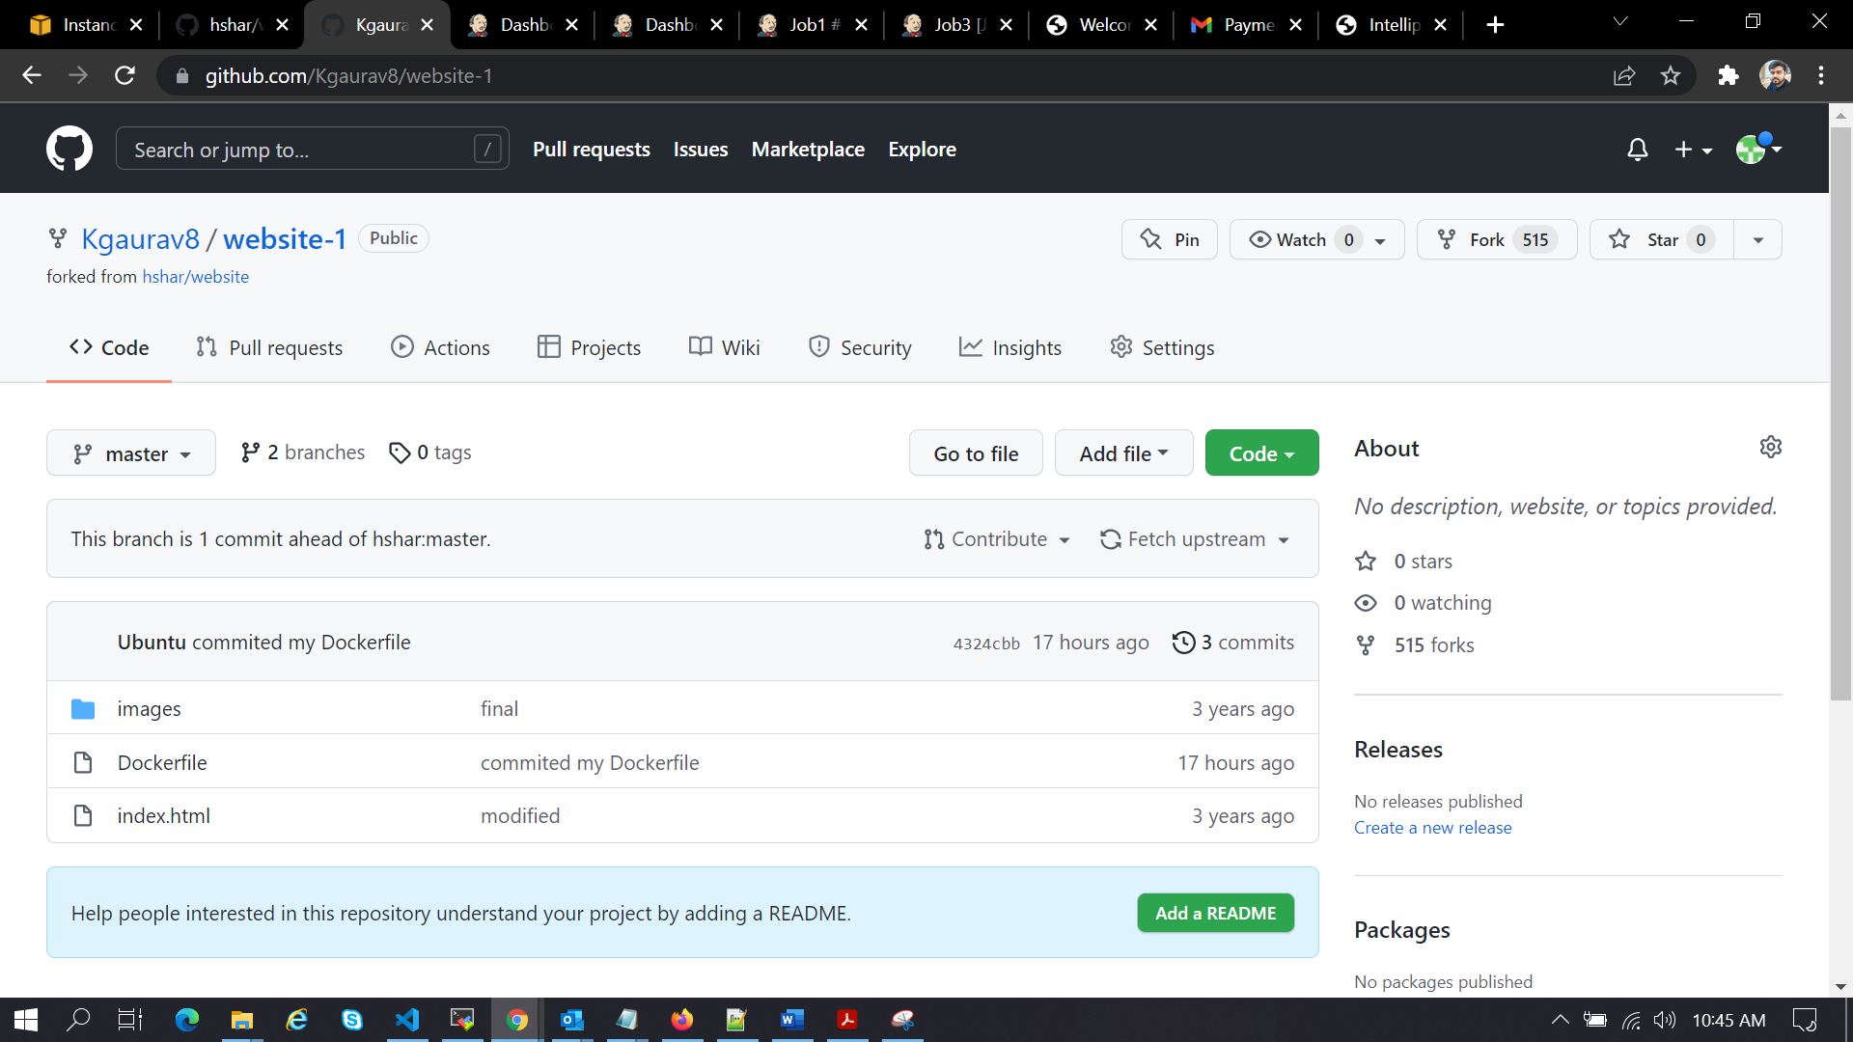

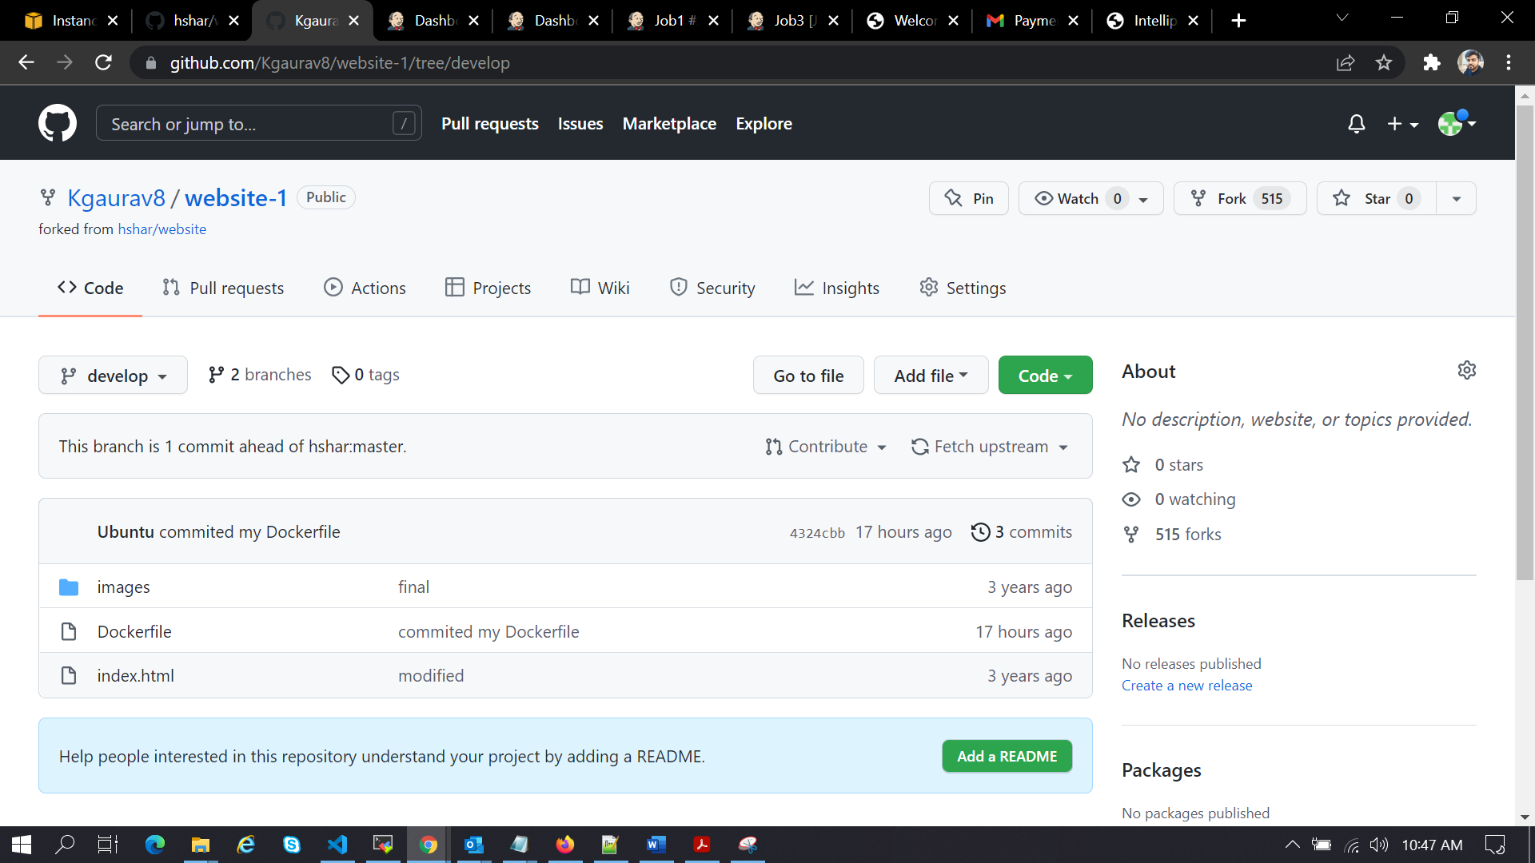

Here I pushed Dockerfile from ec2-server to both **master and develop** branch.

Dockerfile on master:

FROM nginx

ADD . /usr/share/nginx/html

---

Job1:-

sudo docker rm -f $(sudo docker ps -a -q)

sudo docker build /home/ubuntu/jenkins/workspace/Job1 -t app1

sudo docker run -itd --name c1 -p 82:80 app1

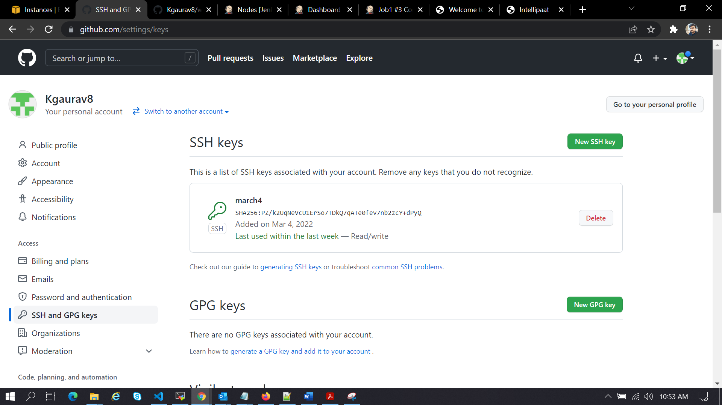

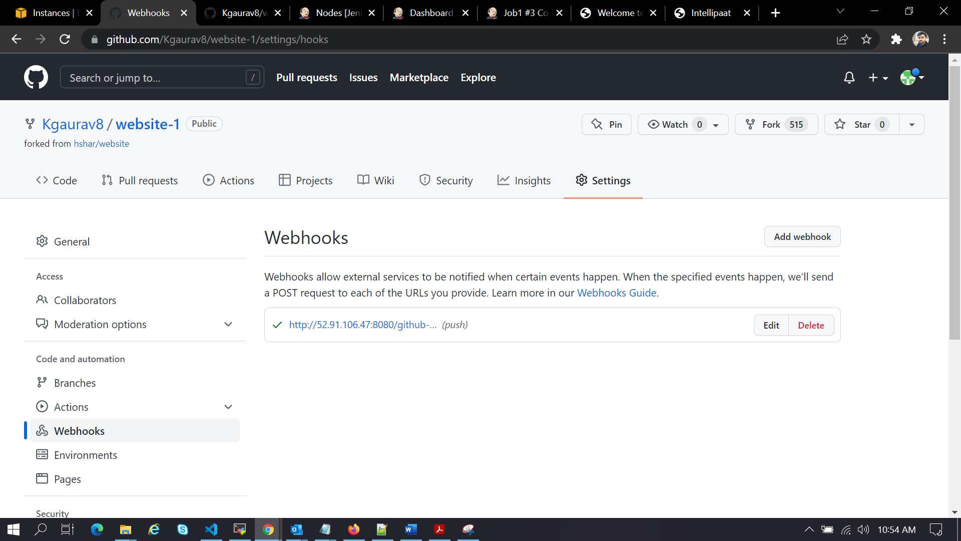

Also did configuration for Jenkins webhook and ssh key config in github for ssh cloning authentication

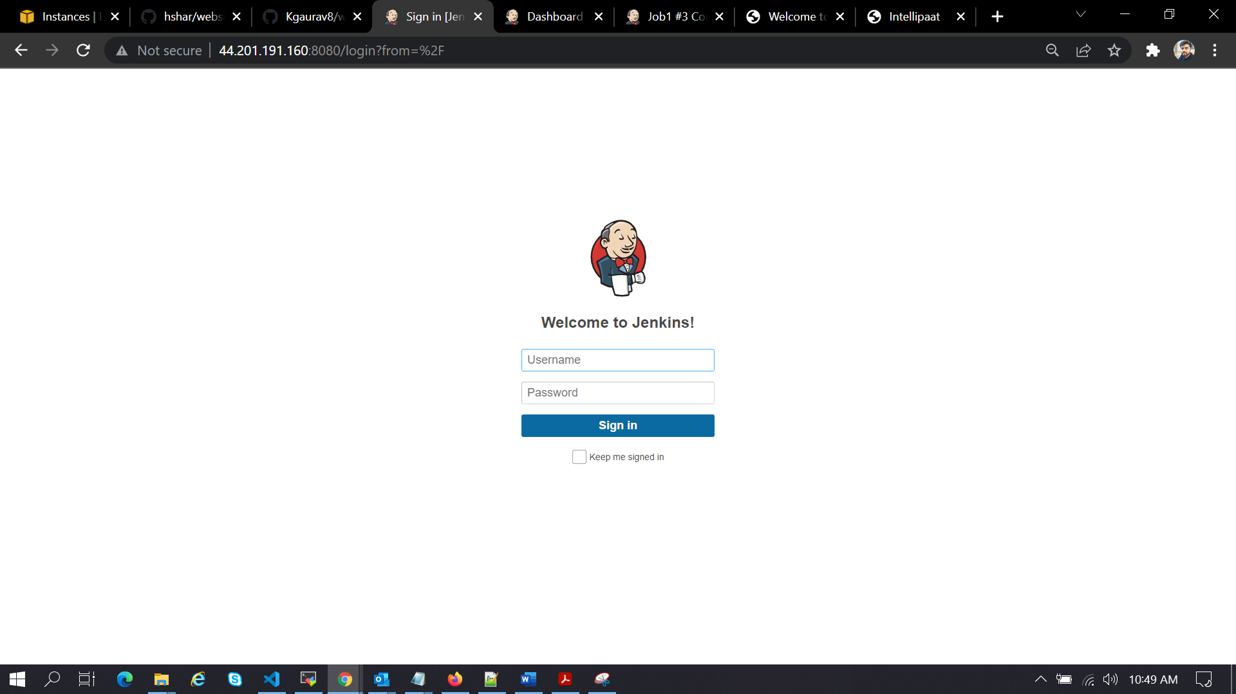

I setup the Jenkins and logged in.

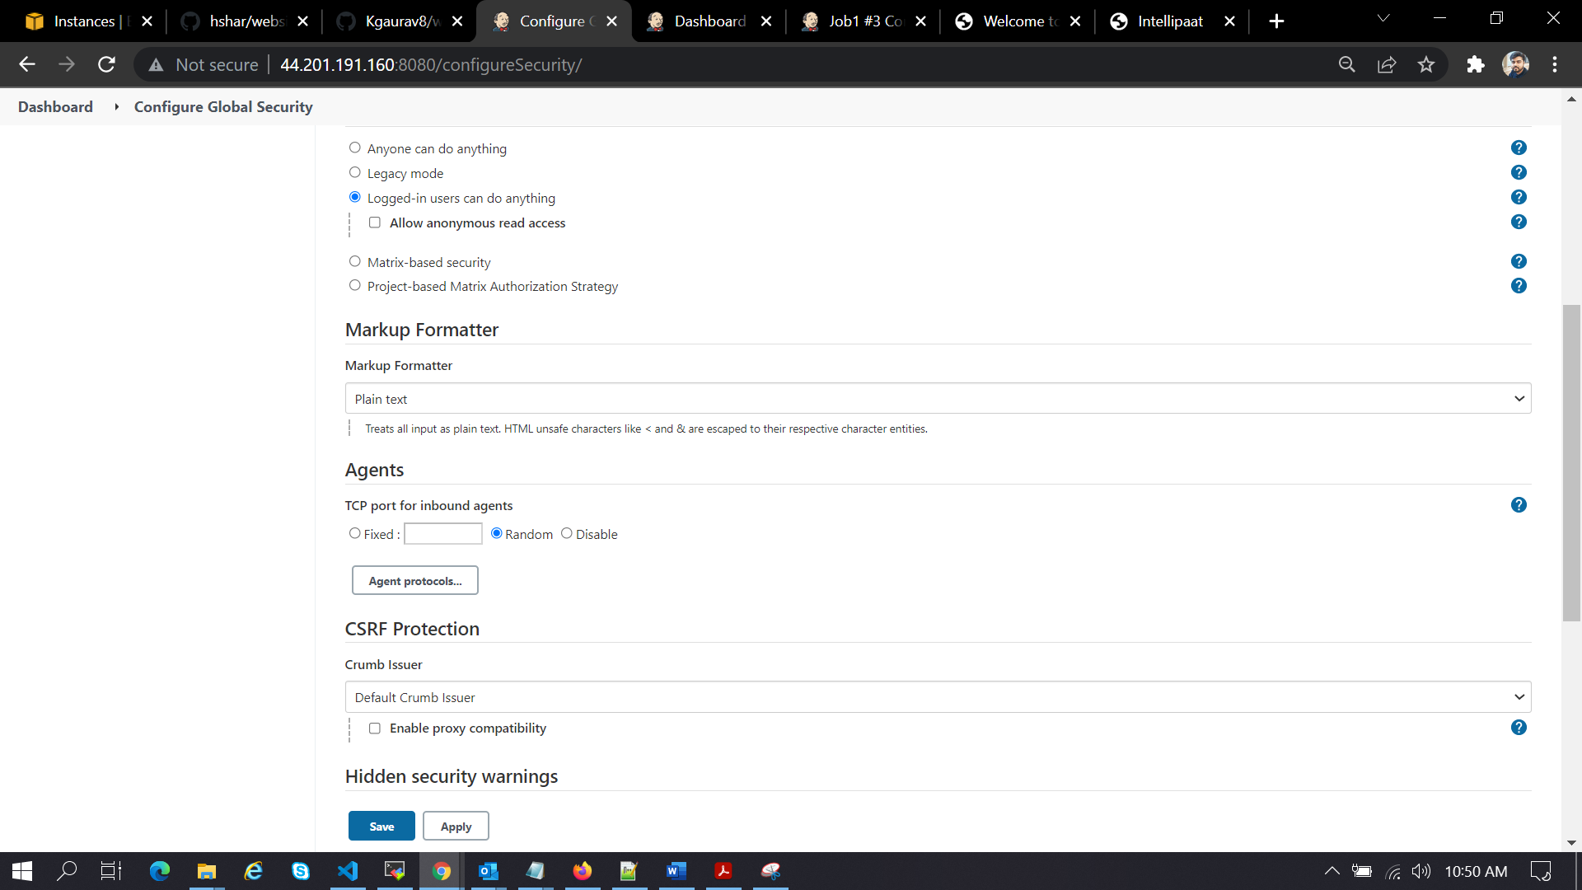

Changed the TCP under manage Jenkins 🡪 configure global security🡪 agents🡪chose random

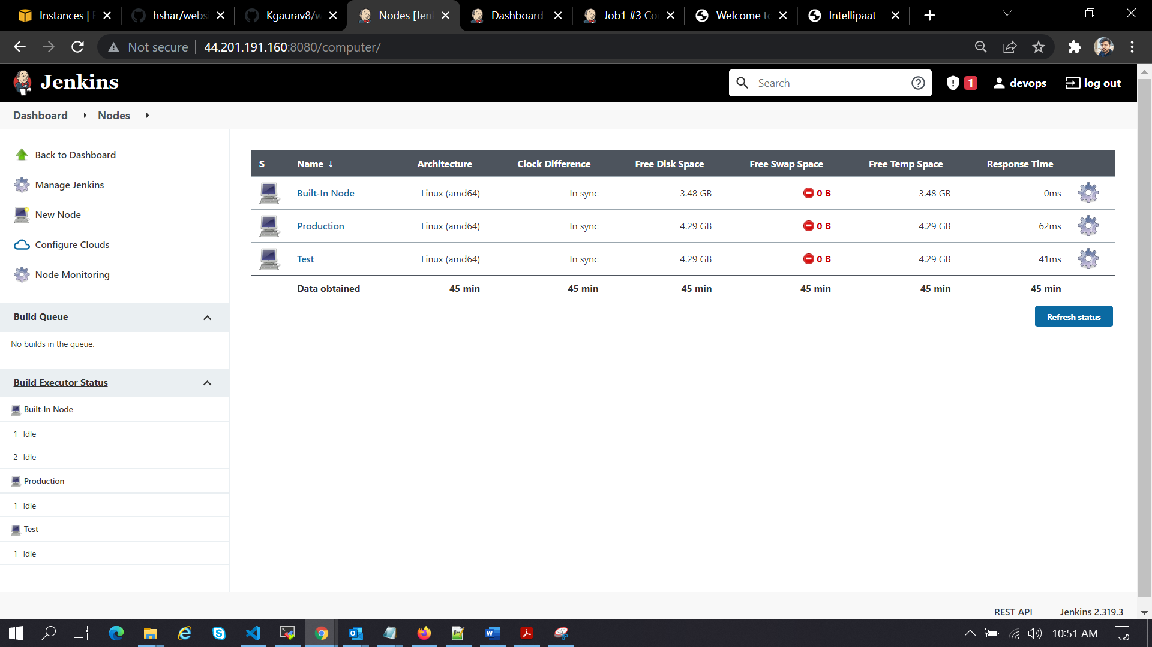

Created Nodes for develop and master activity (test and Production)

Created job1 and job2 and job 3 for test,develop and master branch config

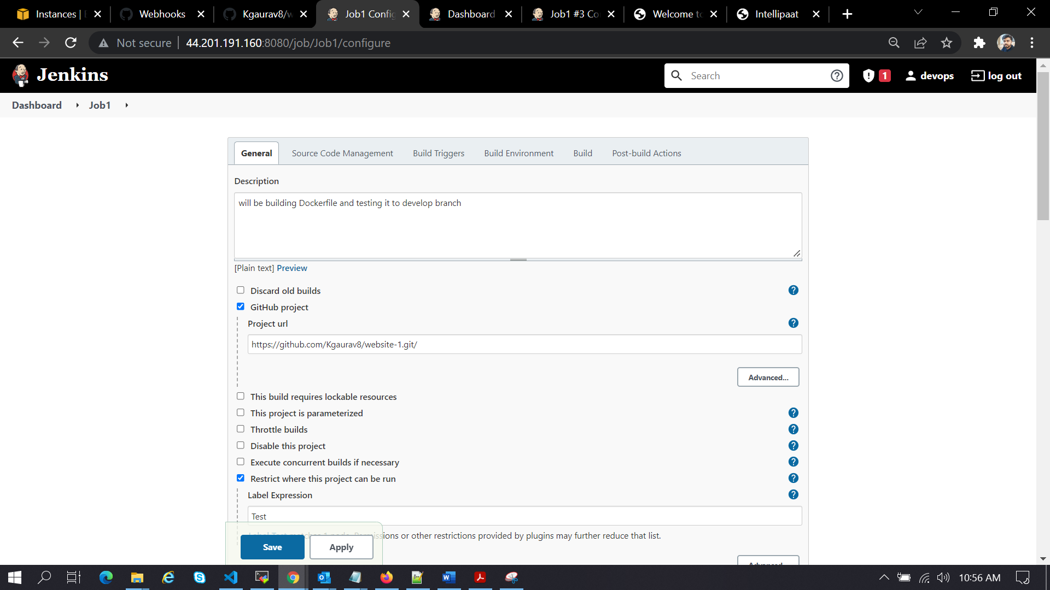

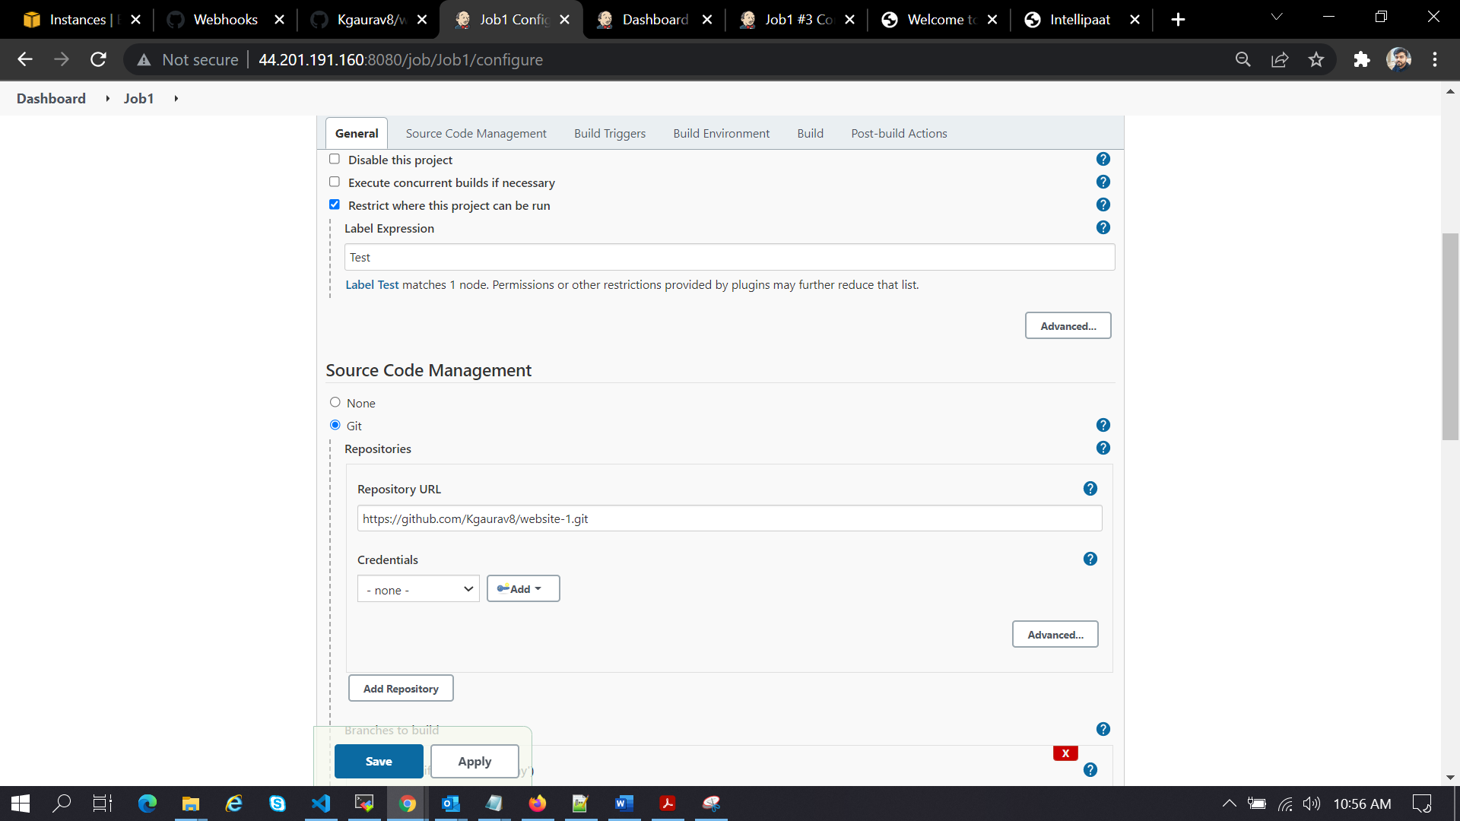

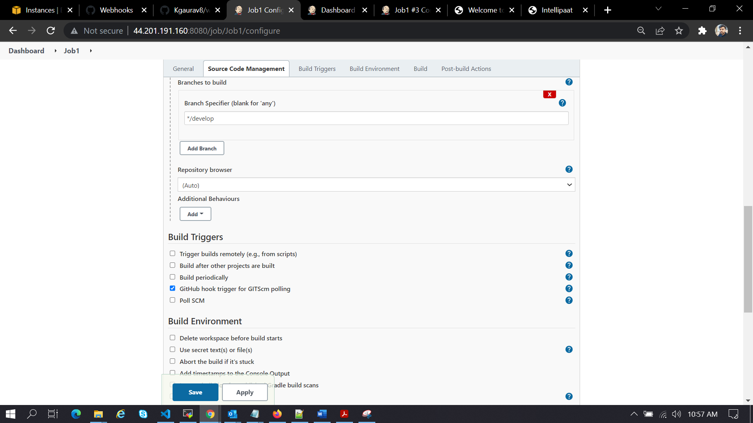

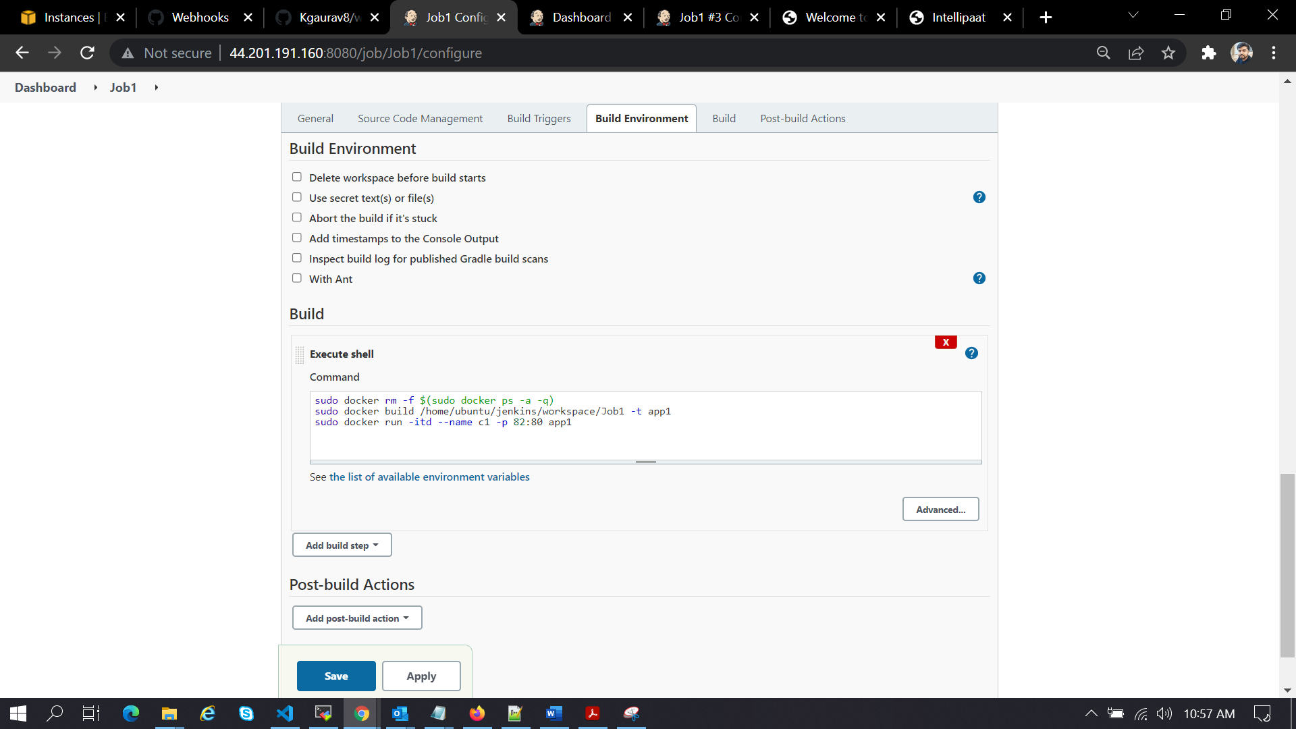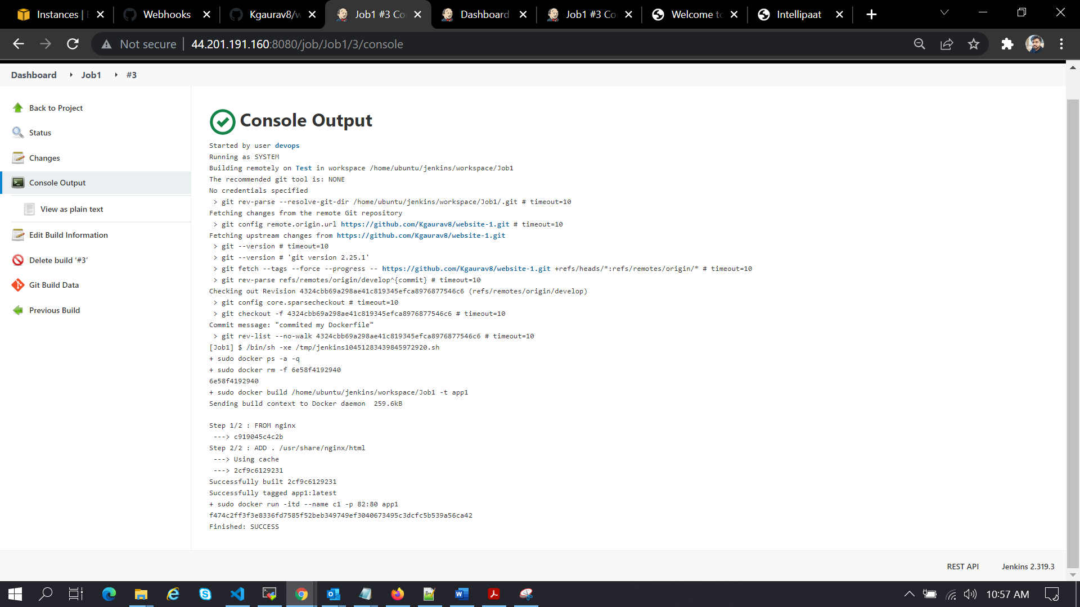

Job2:

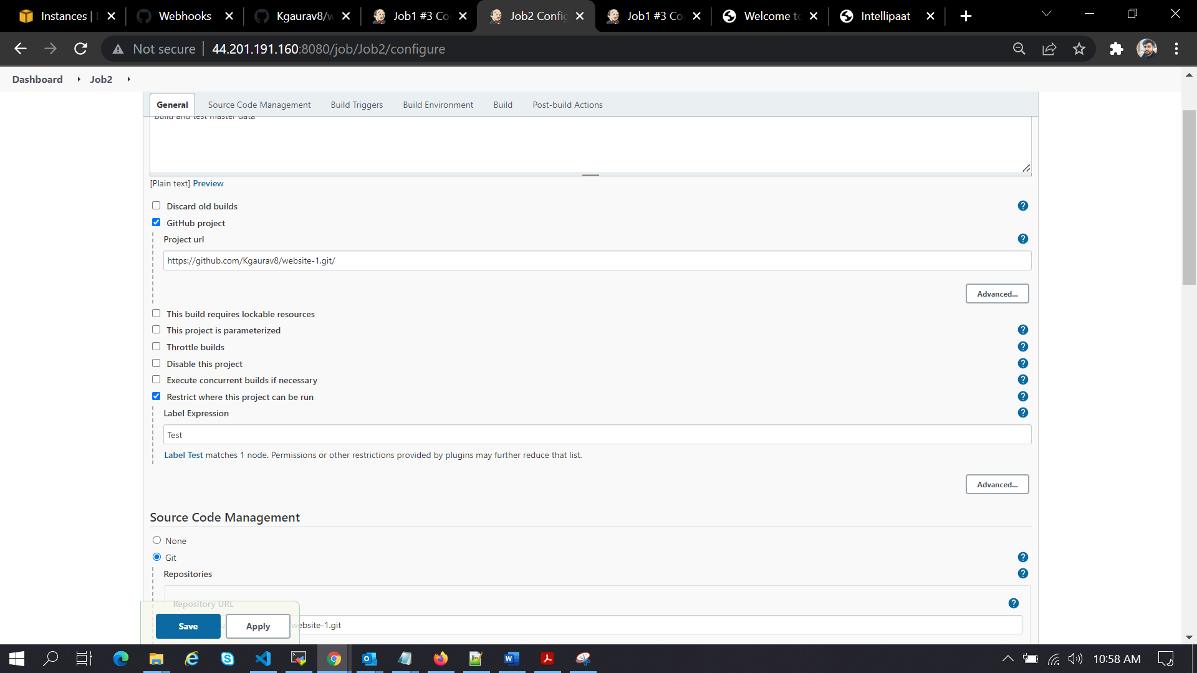

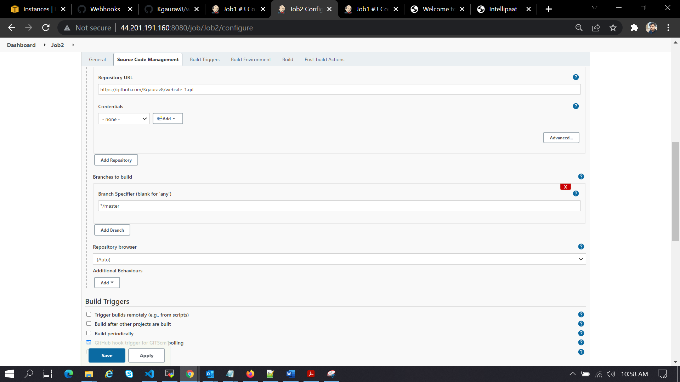

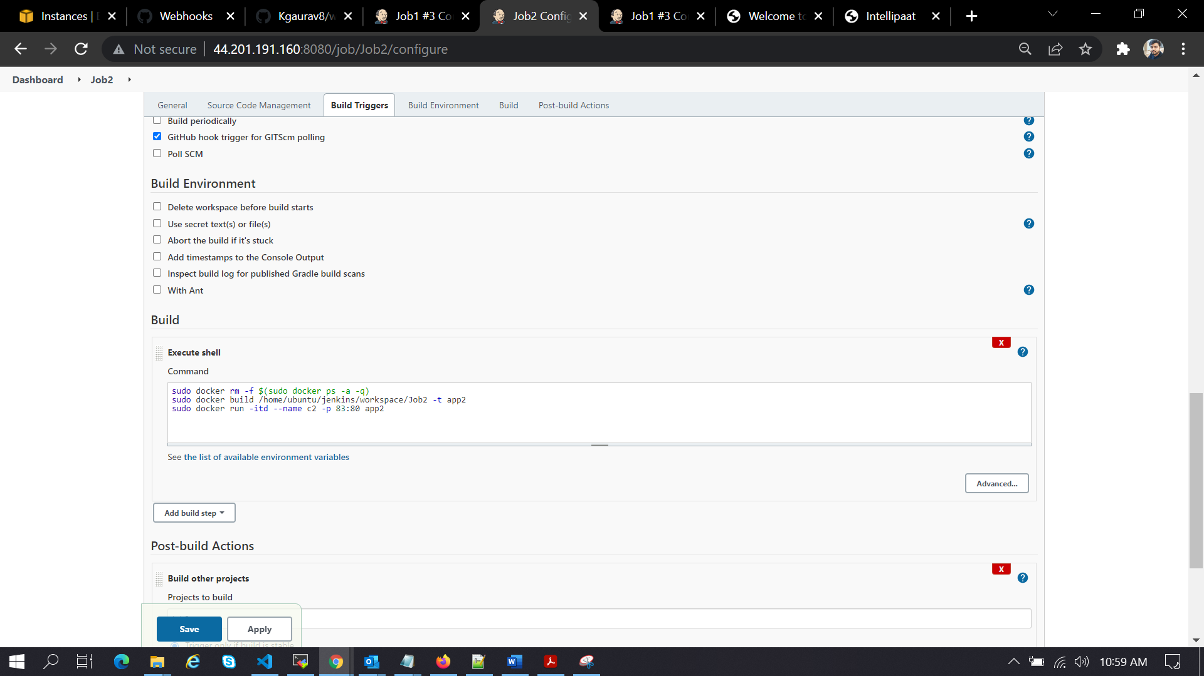

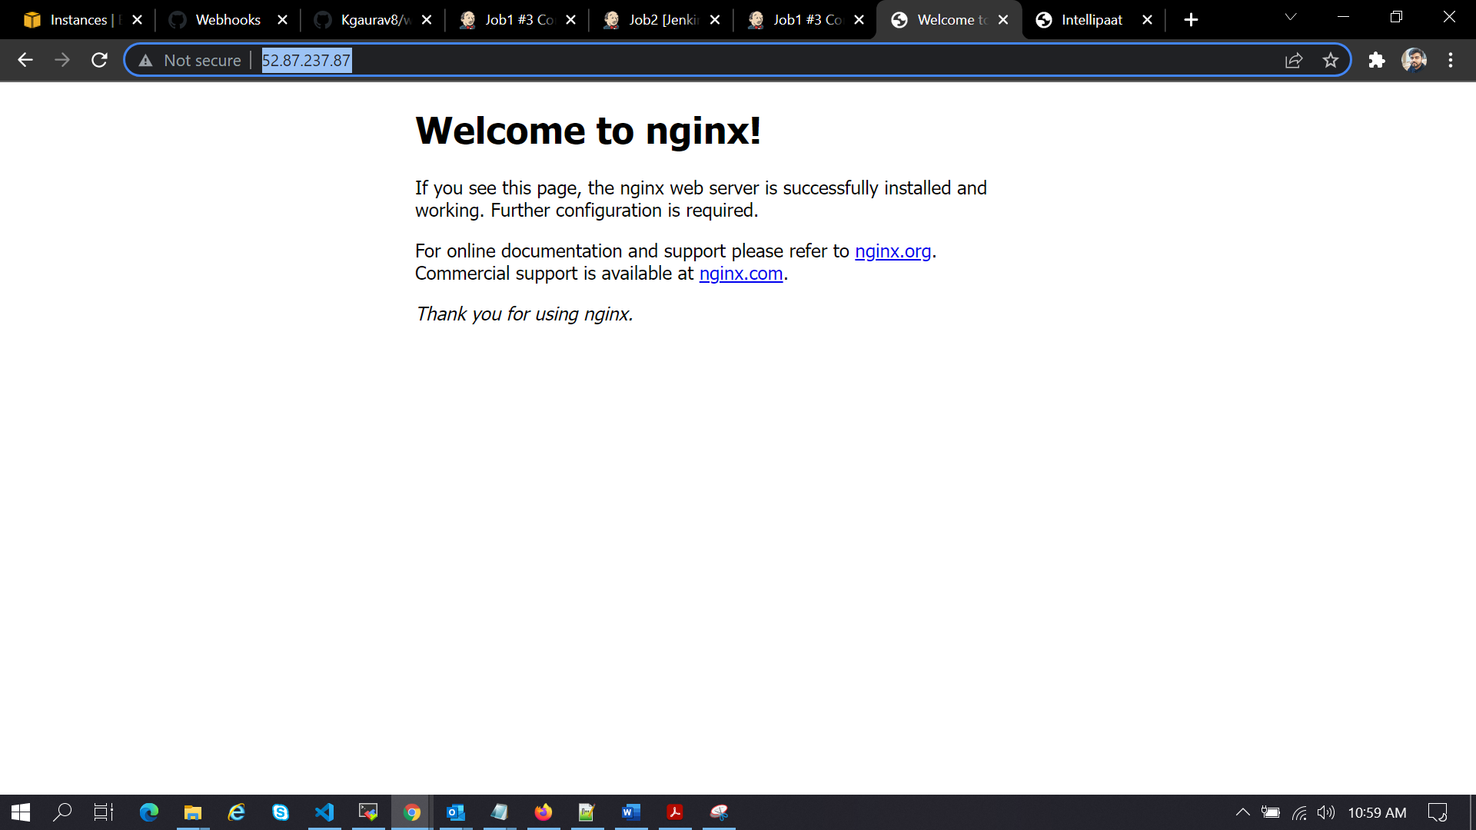

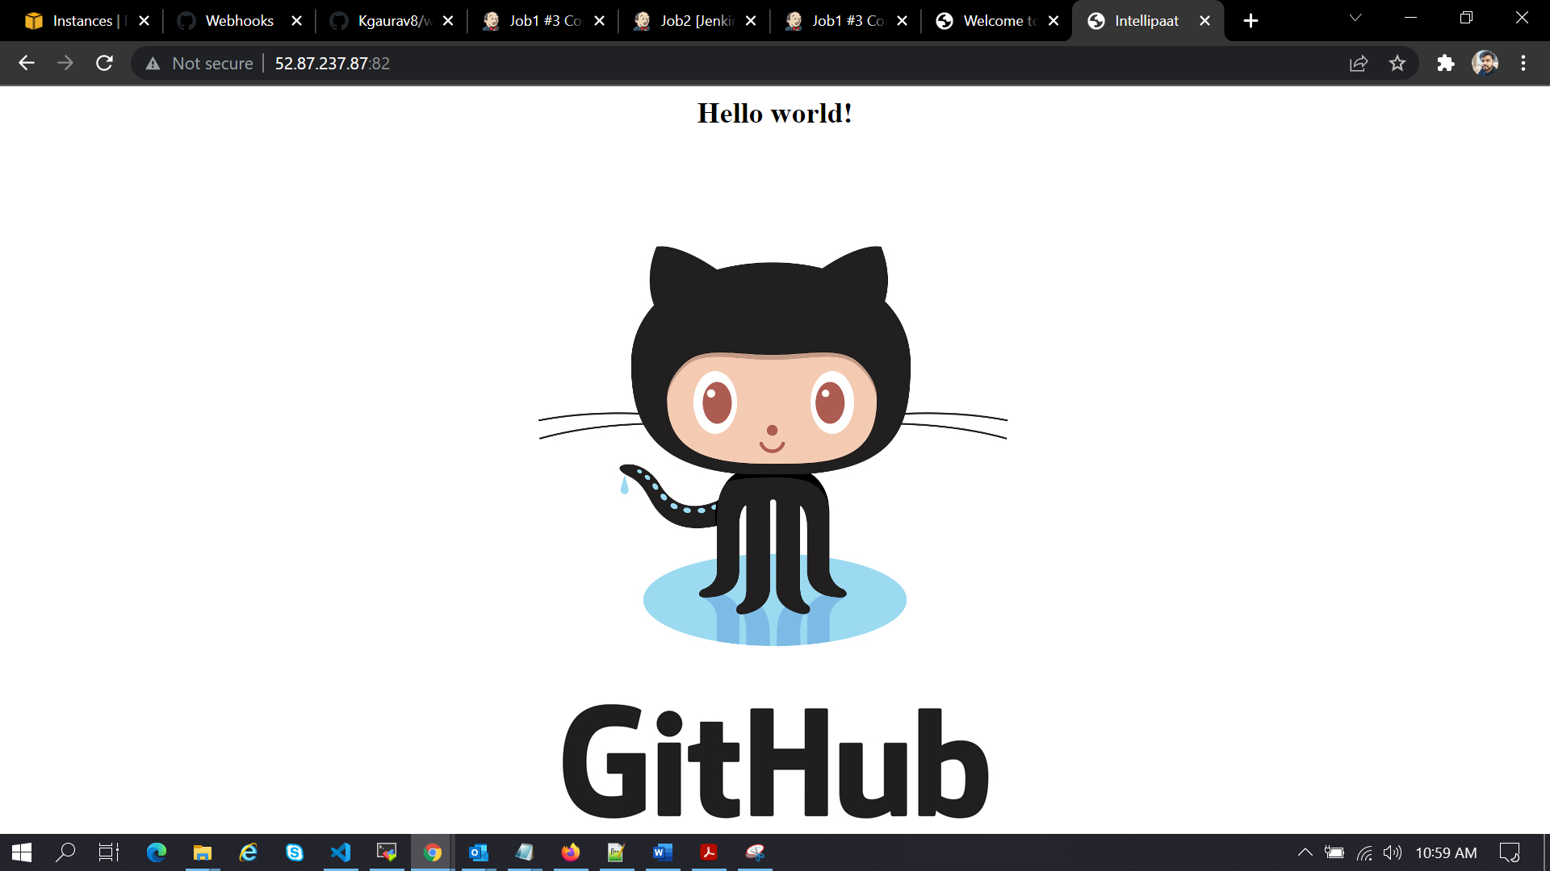

Here I can see my output as per requirement.